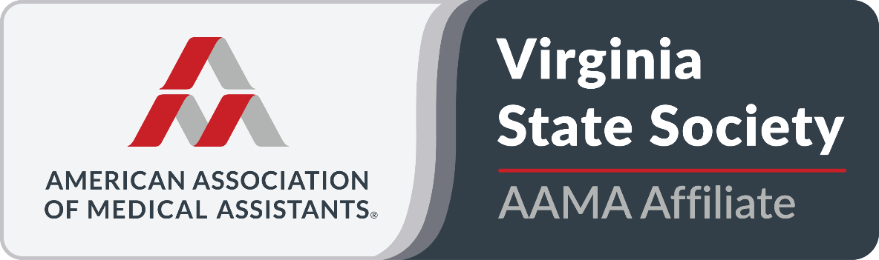

April 11, 2026
Bryant & Stratton
301 Centre Pointe Drive
Virginia Beach, VA 23462

Friday, April 10, 2026:
7:00 PM – Executive Board Meeting (location TBD – all members welcome to attend)

Saturday, April 11, 2021 (4 CEUs)
8:00-8:30 AM – Registration and Welcome
8:30-10:00 AM – Workplace Violence – Virginia Beach Police Department
10:00-10:30 AM – Break with vendors
10:30-12:00 PM – Active Shooter – Virginia Beach Police Department
12:00-1:00 PM – Lunch (INCLUDED)
1:00-2:00 PM – GLP1s and Weight Loss – Medi Weight Loss
2:00-2:30 PM – Break
2:30-4:00 PM – Signs of Human Trafficking in the Medical Office and Actions to Take –
FreeKind (Freekindva.org)
4:00-5 PM VSMA Annual meeting – ALL MEMBERS ARE ENCOURAGED TO ATTEND
5 PM – Raffles and closing remarks

The VSMA/AAMA reserves the right to use any photograph/videography taken at any VSMA/AAMA event—without further notification—within VSMA/AAMA print and/or electronic materials, including, but not limited to, the website, AAMA Excel Award applications, and in videos and social media platforms. By registering for and attending the VSMA Annual Conference or Fall Education Seminar, you agree to permit the VSMA/AAMA to use photographs and/or video featuring your likeness at the VSMA/AAMA’s sole discretion.
Hotel block has been arranged at the Hilton Garden Inn Town Center, Virginia Beach, 252 Town Center Dr, Virginia Beach, VA 23462. The cost of hotel rooms is $129 (plus taxes) for king-size and double good 4/10-12. The hotel has free parking. Registered guests of the group will receive $4 off breakfast coupons per night per registered guest. Reservations may be made at https://hll.tn/n6hxm8 (group code 90V) or by calling Central Registration at 877-782-9444 and mentioning group code 90V. Book early – only 15 rooms are being held. If you plan to arrive before 4/10/26 or plan to stay later than 4/12/26, please call 757-448-2101 to make your reservation. Only 4/10/26-4/12/26 will be available via the link or when calling Central Registration. The group rate will only be honored for one day before/after VSMAs' contracted dates.
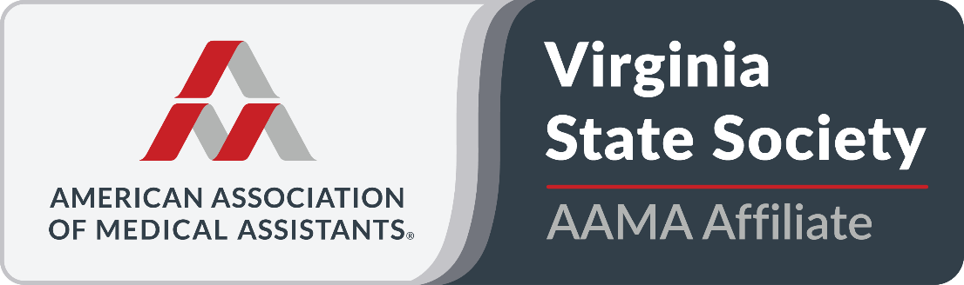

Name: ____________________________________________ Credential: __________________

Address: ______________________________________________________________________

Phone: ________________ Email: ________________________________________________

First-time attendee? ______ Student? _____ School: _________________________________

PRICING:
If paid before/by March 15, 2026
____ Student $15 ____ VSMA Members $45 (Member #_________) ____ Non-Member $55

If paid after March 15, 2026
____ Student $15 ___ VSMA Members $50 (Member #_________) ____ Non-Member $60

Discounted Corporate rate: $40 each for 3 or more registered from the same employer

Fee includes Saturday CEU sessions and Saturday lunch (please note allergies or special dietary needs). Registration Deadline is April 6, 2026. There is a $10.00 late fee for all registrations received after April 6, 2026. Registrations received after the deadline will not be included in the lunch count. Any requests for refunds will be discussed by the Executive Board.

Dietary needs/ allergies: _________________________________________________________
NOTE: There will be no coffee or breakfast available on Saturday.
LUNCH: TBD

Send registration to: Debby Houston, CMA (AAMA)
31 Sky Manor Rd
Staunton, VA 24401

Make check payable to: VSMA
There will be an online option for registration. Please see VASMA.org for the link.

